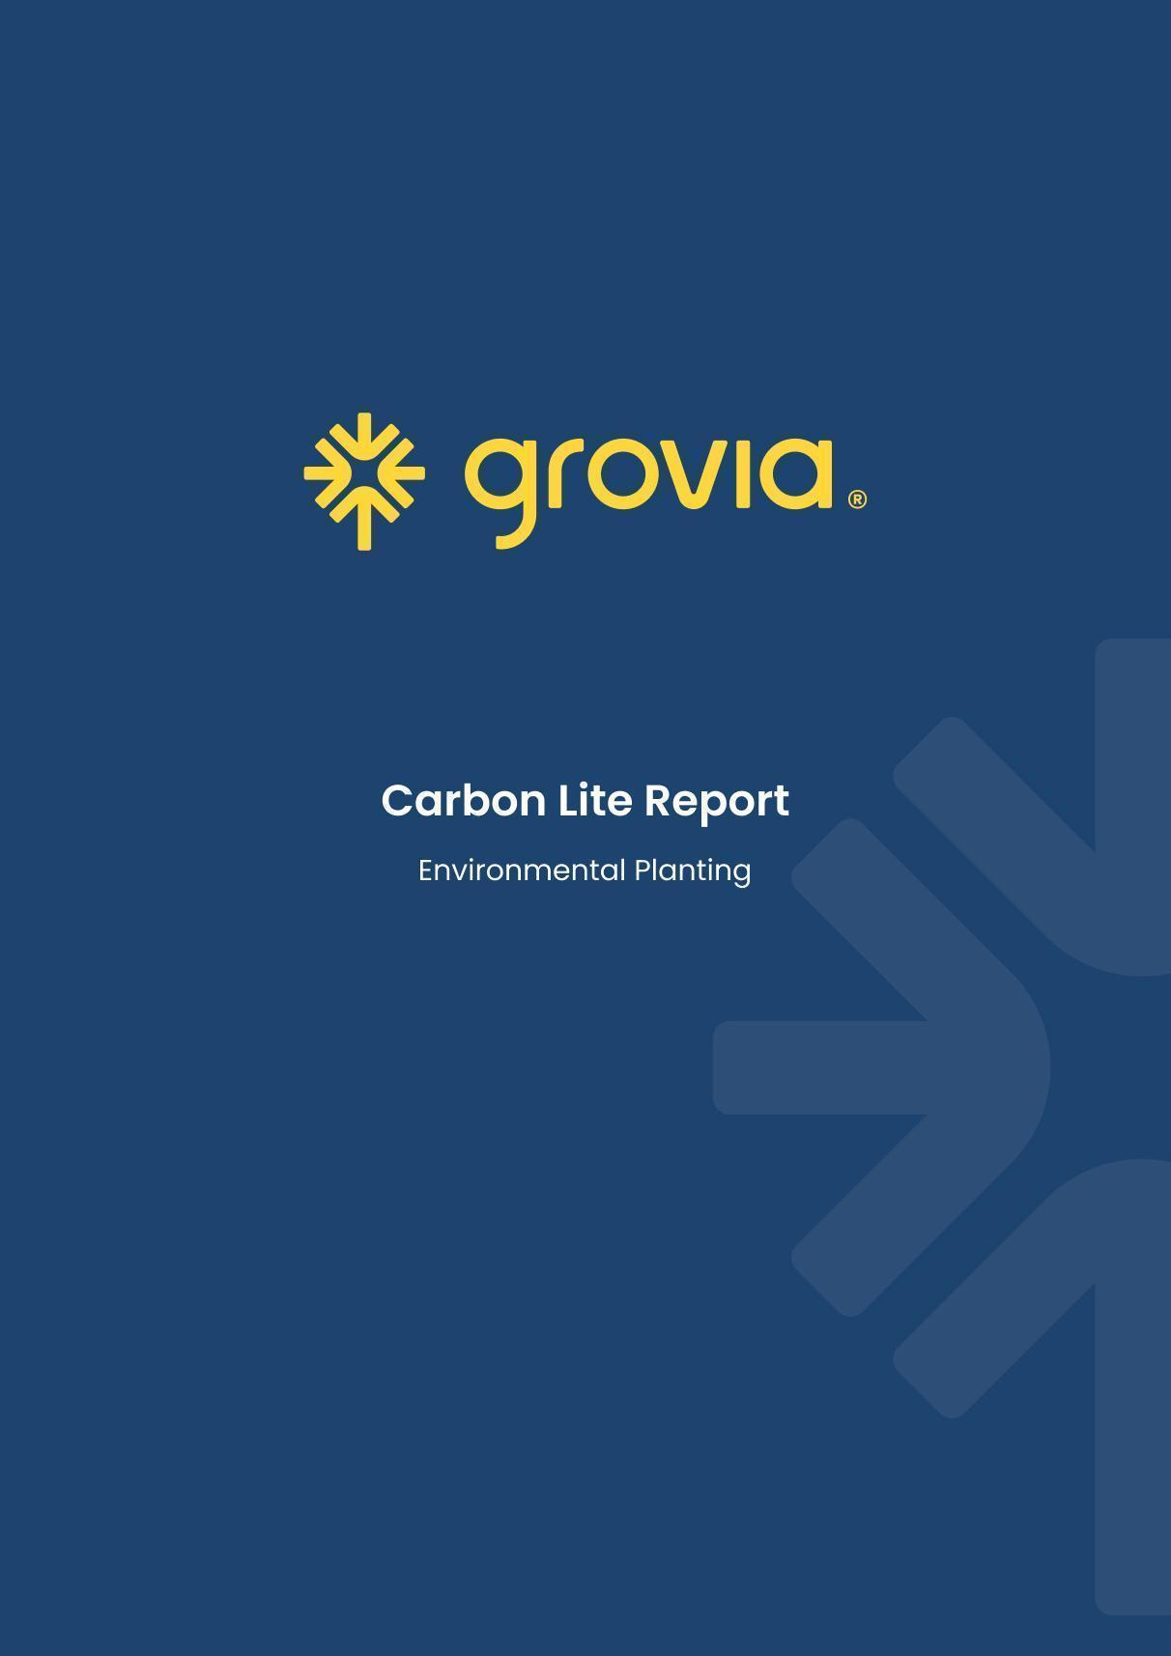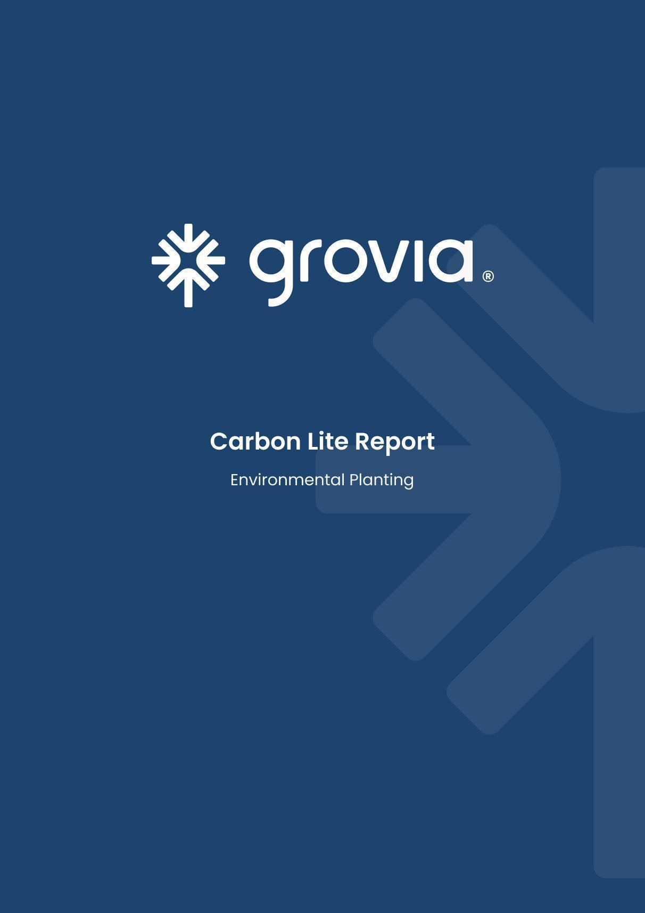

Kalimna

15 July 2024

# Introduction

The following **Carbon Lite Report** is a property-specific assessment of select variables that are important to consider when assessing the feasibility of developing an Environmental Planting (EP) project. Information in the report is designed as a free initial desktop assessment of the potential opportunity and obstacles to project development. The information is indicative and reflects only a small proportion of the factors requiring critical review in the decision-making process. (See ‘What else is involved in an EP project?’ section for more information).

## What is an Environmental Planting?

EP is a vegetation-based carbon method that allows landholders to generate Australian Carbon Credit Units (ACCUs) by restoring native flora on cleared land[1]. EP involves the planting and maintaining of native and local plant species that represent various growth forms such as trees, shrubs and understorey plants (hereafter referred to as biodiverse plantings). The method is administered by the Clean Energy Regulator, with detailed eligibility and compliance requirements outlined in legislation[2].

## Why are EP carbon projects important?

EP carbon projects provide landholders the opportunity to diversify revenue streams by integrating an alternative land use into existing land management practices. Historically, EP carbon projects generate high quality ACCUs that are often valued more highly than credits generated from other carbon methods.

EP biodiverse plantings may also bring additional socio-economic and environmental benefits. These include, but are not limited to, creating economic opportunities for regional communities, establishing pathways for engagement and business opportunities for local First Nations groups, improving local biodiversity, enhancing ecosystem services, and strengthening landscape resilience.

Habitat loss is the primary driver of biodiversity decline in Australia. Implementing EP carbon projects offers a scalable solution to restore biodiversity on private lands. These projects can help mitigate the impacts of habitat loss while facilitating the recovery of critical ecosystems.

# Property overview

This section provides an overview of the property and carbon assessment.

Table 1: Summary of Assessment

|  |  |
| --- | --- |
| **Item Assessed** | **Assessment** |
| Planting Area | **Low risk.** Less than 5% of the total planting area is classified as ‘ineligible’. |
| Carbon Returns | **Moderate returns**. 12.0 ACCUs / ha / year |
| Slope | **Low risk.** Slope within the planting area can be described as flat to undulating and present as a low risk for site operations. |

Table 2: Kalimna, NSW overview

|  |  |
| --- | --- |
| **Attribute** | **Details** |
| Property Name | Kalimna |
| Property size | 1823 ha |
| Address / Location | Kalimna, NSW |
| Planting Area | 889.79 ha |
| Ineligible Area[3] | 31.35 ha |
| Total ACCUs generated (gross) | 464,580 ACCUs |
| Total ACCUs (net) - for 25 years* | 348,069 ACCUs |
| Total ACCUs (net) - for 100 years** | 440,887 ACCUs |
| * Inclusive of 20% permanence period discount and 5% risk of reversal buffer  ** Inclusive of 5% risk of reversal buffer | |

|  |  |
| --- | --- |
| Mya | Hi |
| Hello  popppins | Dsfa |
| Dfas |
| fas | dsaf |

# Supporting Details

This section presents a visual overview of the property-specific information to consider when determining the feasibility of developing an Environmental Planting (EP) project.

## Planting Area

The area that may be suitable for planting within your designated project area.

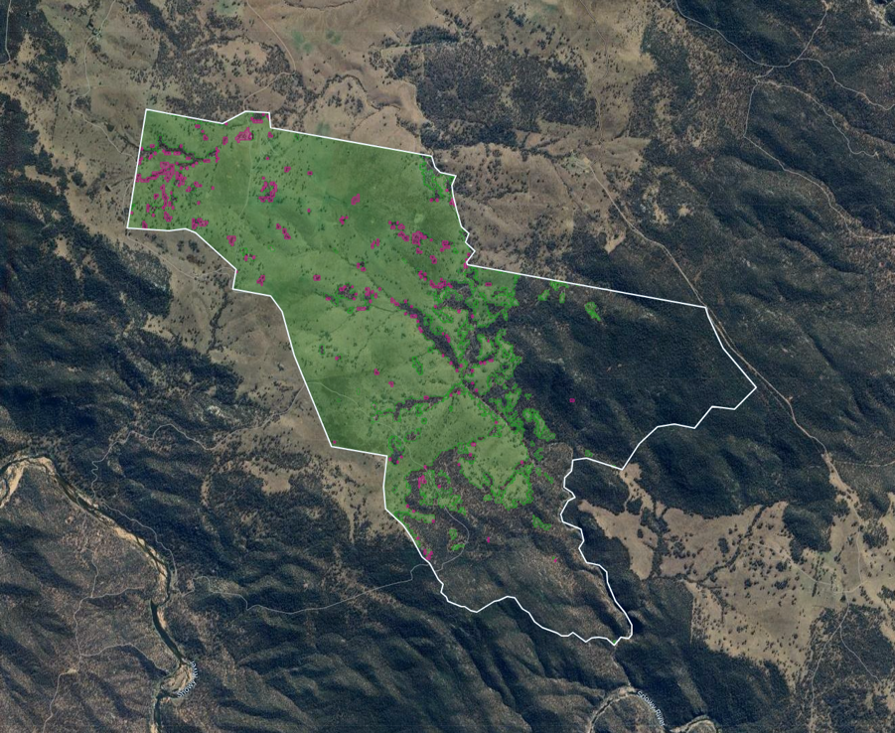*Figure 1: Boundary map of Kalimna, NSW property. Green polygons correspond to non-woody areas and pink polygons represent areas where ‘forest loss’ is likely to have occurred.*

Table 3: Summary of the woody vegetation cover of the of Kalimna property estimated by grovia – National Forest and Sparse Woody Vegetation Data, 2022.

| **Category** | **Total Area (ha)** | **Percent cover (%)** |
| --- | --- | --- |
| Non-woody (eligible) | 889.79 | 51.66 |
| Non-woody (ineligible)* | 31.35 | 1.72 |
| Sparse woody vegetation | 45.82 | 2.51 |
| Woody vegetation (forest) | 856.17 | 46.96 |
| Total | 1823.14 | 100.00 |

* The National Forest and Sparse Woody Vegetation data indicates that woody vegetation loss has likely occurred in the past 7 years.

## Carbon heatmap

A carbon heatmap visually represents the distribution and capacity of the land to store aboveground carbon. This allows you to review and optimise your planting area based on the potential carbon yield.

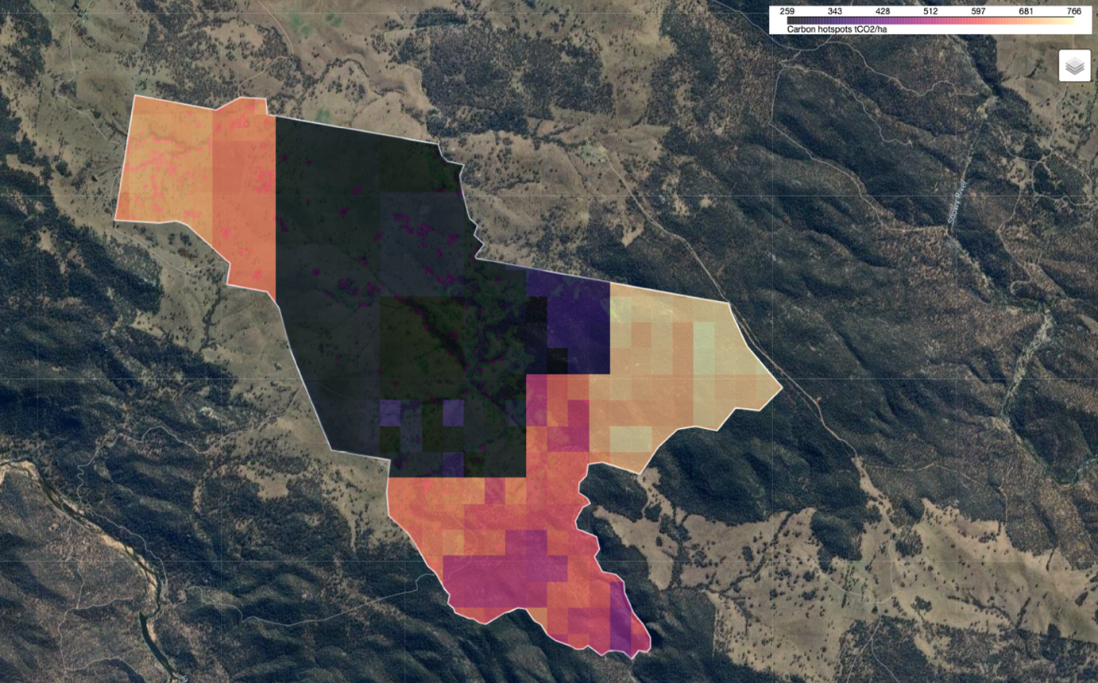*Figure 2: Carbon heatmap of Kalimna property.*

## 

## Slope

Slope is an important consideration for assessing EP carbon projects as it can directly influence future planting operations such as the operation of heavy machinery or by limiting accessibility. This section provides an overview of the topography of the specified project area.

*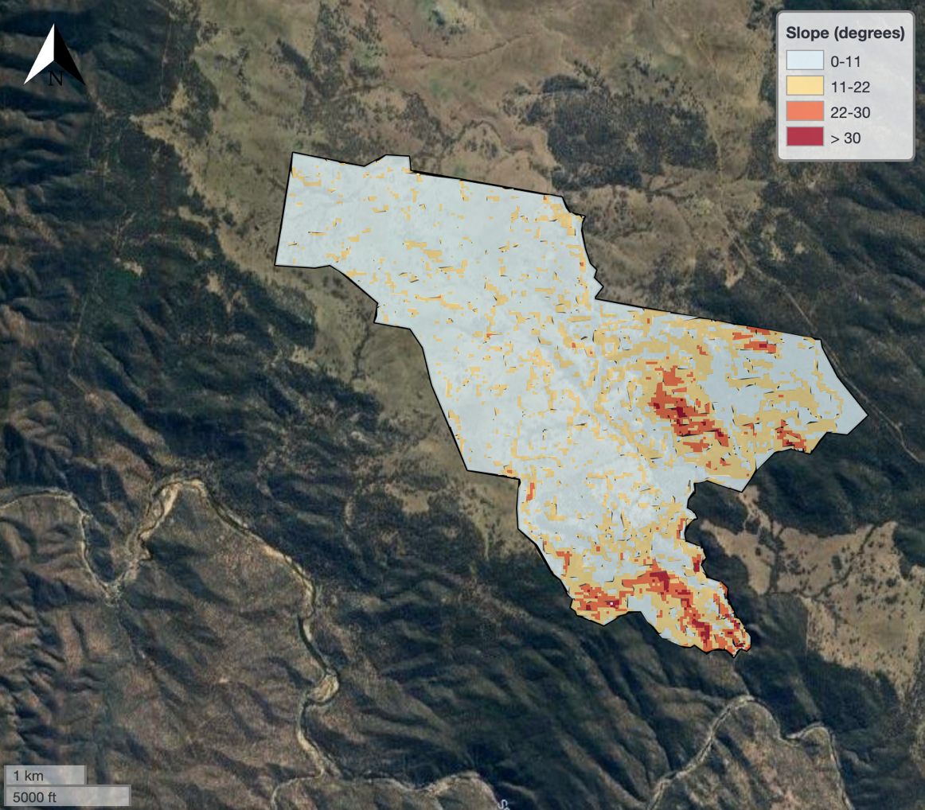Figure 3: Slope (degrees) at the Kalimna property.*

Table 4: Planting area defined by slope.

|  |  |  |
| --- | --- | --- |
| **Slope (degrees)** | **Planting Area (ha)** | **Planting Area (%)** |
| 0 – 10 | 749.38 | 84.22 |
| 10 - 15 | 120.27 | 12.77 |
| 15-20 | 16.15 | 1.71 |
| 20-30 | 3.80 | 0.40 |
| >=30 | 0.19 | 0.02 |
| Total | 889.79 | 100.00 |

# What else is involved with an EP project?

Evaluating the feasibility of an EP project requires the analysis of additional factors that may influence project development. For example, environmental conditions such as soil type, vegetation classifications, long-term climatic conditions, and exposure to natural hazards can significantly influence the overall viability of developing a biodiverse planting, and ultimately determines whether a property is suitable to progress.

Project proponents[4] are also required to assess additional risks such as whether there is a legal right to develop a project by considering variables such as land tenure, zoning, native title claims and how regional and local strategic plans may impede project establishment.

It is also beneficial for project proponents to have a high degree of confidence that the carbon sequestration potential of a project is accurate. For EP carbon projects, this requires a method-compliant workflow of project stratification, followed by modelling the projects potential ACCU generation through the Full Carbon Accounting Model (FullCAM) software5.

After a desktop assessment, a site visit is highly recommended as it offers the opportunity to ground-truth the information gathered in this report and to also reassess how these variables meet (or do not meet) project eligibility requirements. For example, information from a site visit will likely inform the recalculation of the potential ACCUs generated from a project by refining the planting and exclusion areas.

If a project is deemed feasible and worth developing further, the next steps are summarised in figure 4 below:

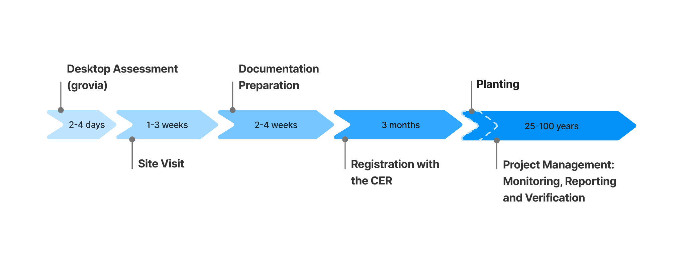*Figure 4: A timeline outlining the key stages of a carbon project, from initial desktop assessment and site visits to CER project registration and ongoing monitoring, reporting, and verification post-planting.*



# Next steps on grovia

The grovia platform is designed to help you streamline the steps outlined in figure 5; from further assessing the feasibility of a project with site visit data, to optimising planting efforts and fine-scale tracking of project success with our measurement, reporting, and verification (MRV) data management module.

As a first next step, grovia’s **Carbon Pro+ Report** provides a comprehensive evaluation of your project’s feasibility and viability by critically assessing accordance to environmental conditions. It utilises a proprietary machine learning model that provides an accurate estimate of a projects planting area and subsequently, the potential carbon that can be sequestered by your project and the ACCUs you can claim in return.

Our expert team will work with you to understand all your project goals and ensure the project is delivered to a high standard and with integrity. If you would like to request a report, or have any questions, please get in touch [*contact@grovia.earth*](mailto:contact@grovia.earth).

1. Areas designated for planting under the Reforestation by Environmental or Mallee planting method must not have had forest cover within the past 5 years. Furthermore, all CER carbon projects that involve establishing vegetation on land require that there must not have been clearing of any native forest within the 7 years of lodging the application (5 years if the land has changed ownership since the clearing). grovia’s initial assessment flags the likelihood that a property may encounter issues with eligibility if the project was to progress. grovia recommends that a site visit and further investigation is required to ground-truth these results.
2. Carbon Credits (Carbon Farming Initiative) (Reforestation by Environmental or Mallee Plantings - FullCAM) Methodology Determination 2024), Carbon Credits (Carbon Farming Initiative) Act 2011 (the CFI Act), Carbon Credits (Carbon Farming Initiative) Rule 2015.
3. Environmental Planting carbon projects cannot be developed on land that contains or needs clearing of woody biomass. If land clearing has occurred, the clearing event must have occurred at least 5 years prior to project application or seven years if property has undergone no recent change in ownership. The grovia platform assesses for evidence of land clearing within the last 7 years and areas with identified ‘forest loss’ is classified as ‘ineligible’ for project development. Areas that have existing woody biomass are omitted from the planting area.
4. A project proponent is the party who has the legal right to develop a project and is responsible for carrying out the project, is issued credits for the project and is legally responsible for meeting all obligations under the law. See <https://cer.gov.au/schemes/australian-carbon-credit-unit-scheme/how-to-participate/plan-your-project/choose-project-proponent> for more information.

   5 <https://www.dcceew.gov.au/climate-change/publications/full-carbon-accounting-model-fullcam>